How To Assembly:
- Set up before programming:
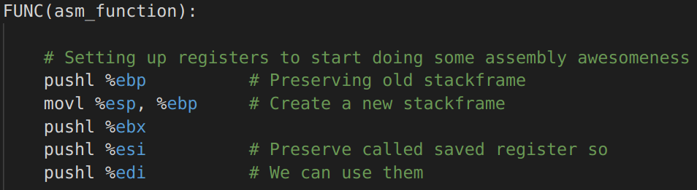

- Function for adding two numbers and returning them

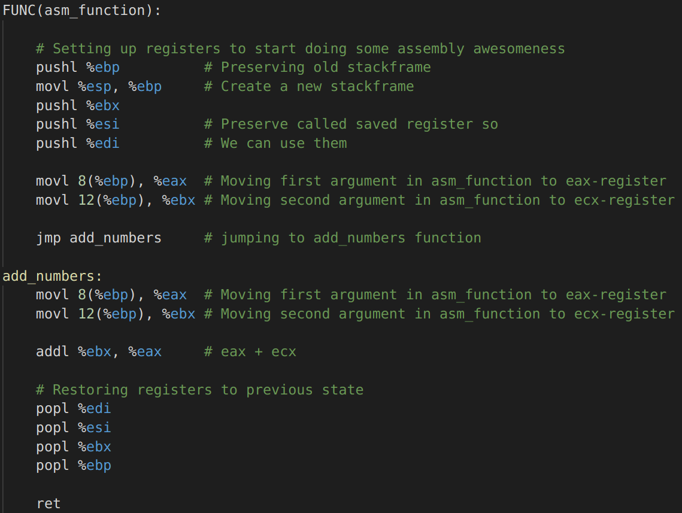

- While-loop
